*Exercise:2*

*Date:12/10/2020*

*AIM:*

*To write a Python program to count the number of x in the given list of number.*

*PROGRAM:*

*def countX(lst,x):*

*c= 0*

*for I in range(len(lst)):*

*if(x==lst[i]):*

*c=c+1*

*return c*

*lst=[]*

*n=int(input())*

*for _ in range(n):*

*lst.append(int(input()))*

*x=int(input())*

*occ=countX(lst,x)*

*print(occ)*

*LINK:*

[*http://103.53.53.18/mod/vpl/forms/edit.php?id=230&userid=1794*](http://103.53.53.18/mod/vpl/forms/edit.php?id=230&userid=1794)

*OUTPUT:*

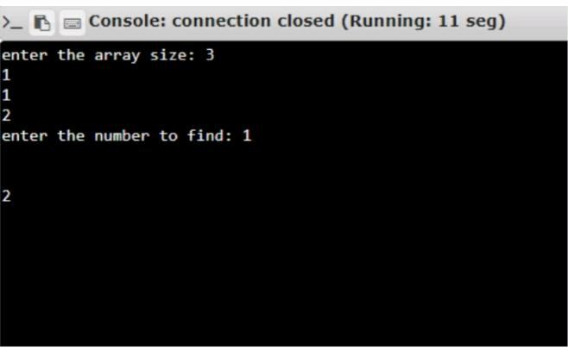

*RESULT:*

*The program to count the number of x in the given list of number is executed and output is verified.*